**Geometry 2023-2023**

**Mr. Reginald Crawford**

**Ms. Micheale Jenkins**

**Ms. Kathy Morgan**

**Mr. Carl Vetar**

**Email address:** [**crawfre@boe.richmond.k12.ga.us**](mailto:crawfre@boe.richmond.k12.ga.us)**,**[**jenkimi@boe.richmond.k12.ga.us**](mailto:jenkimi@boe.richmond.k12.ga.us)**,** [**morgaka@boe.richmond.k12.ga.us**](mailto:morgaka@boe.richmond.k12.ga.us)**,** [**veateca@boe.richmond.k12.ga.us**](mailto:veateca@boe.richmond.k12.ga.us)

**Phone Number: (706)-592-2089      Planning Period: 1th  Period**

**Course Description and Objectives**

In Geometry: Concepts & Connections, instructional time should regularly incorporate the 8 Mathematical Practices, the Framework for Statistical Reasoning, and the Mathematical Modeling Framework through four big ideas of content: (1) numerical reasoning, (2) functional & graphical reasoning, (3) patterning and algebraic reasoning, and (4) geometric and spatial reasoning. This course is designed as the second course in a three-course series. Students will apply their algebraic and geometric reasoning skills to make sense of problems involving geometry, trigonometry, algebra, probability, and statistics. This course enhances students’ geometric, algebraic, graphical, and probabilistic reasoning skills. Students will apply their algebraic and geometric reasoning skills to make sense of problems involving geometry, trigonometry, algebra, probability, and statistics. Students will continue to enhance their analytical geometry and reasoning skills when analyzing and applying a deep understanding of polynomial expressions, proofs, constructions, rigid motions and transformations, similarity, congruence, circles, right triangle trigonometry, geometric measurement, and conditional probability. The identified Prerequisite for this course is Algebra: Concepts & Connections..

**Assignments and Absences**

Students will receive a variety of assignments designed to enhance their learning. If a student is absent, the student need to check Canvas, remind and speak to the teacher about missing assignments upon returning to school.  **It is Students responsibility to contact his or her teacher if they are having trouble or needs assistance.**

**Tutoring Schedule**

Student may attend any math teachers tutoring session:

Mr.Crawford

Ms.Jenkins ( Wednesday, and By appointment, please give 3 days notice)

Ms.Morgan

Mr.Veater

**Course Assessment Plan/Grading Scale:**

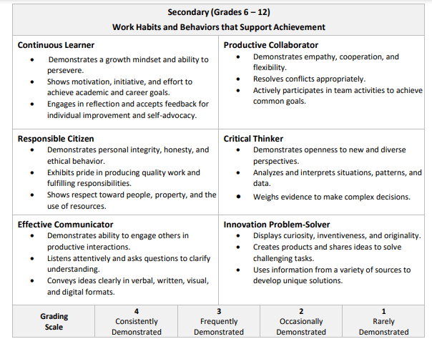

For this course grades will be assigned as follows:

        Major Grades   40%

        Minor Grades 60%

**School Expectations**

Follow all school rules and policies (P.R.I.D.E – PBIS).

* P – Positive
* R – Respectful
* I – Innovative
* D – Determined
* E - Excellence

**CLASS EXPECTATIONS**

**1.**      **Respect yourself, the teacher & others**

•         Show respect for the teacher, yourself and others at all times.

•         Respect others’ property.  Avoid touching or writing on anything that does not belong to you (including desks, textbooks, teacher’s belongings, walls, chalkboard, etc.). Don't expect that others will clean-up your messes. Please pick-up after yourself.

•         Respect yourself and the rest of us by using appropriate language and wearing appropriate clothing.

•         Be a kind person.

**2.**      **Put forth your best effort at all times**

•         Always do your own best work.

•         Put learning ahead of getting good grades.

•         Put quality ahead of just getting it done.

**3.**      **Be prepared for class each day**

•         Come prepared with all materials necessary:

▪         An organized class binder containing all necessary materials and handouts

▪         Loose-leaf paper, pens (blue or black), and pencils

▪         A red or purple pen for grading in class or underlining important elements in note taking

▪         Highlighters for emphasizing important text

**4.**      **Follow directions when given**

•         When directions are given, do your best to follow them the first time.  If you are confused or have questions, ask.  I would rather have you stop class to clarify than be off task while everyone else is working.

**5.**      **Pay attention, participate and ask questions**

•         Engage in what is going on in the classroom.  If you have a question, ask it!  Otherwise, I might not know until the test that you did not understand something.  There are no stupid questions, and chances are, if you are wondering about it, someone else in the class is to.  Be proactive about your learning and don’t be afraid to ask for help.  If you feel most comfortable waiting until after class, that is okay, too, but do keep communication open between us.

**6.**      **Preserve a positive learning environment**

•         Student actions that interfere with teaching or learning in the classroom will NOT be tolerated.

•         Use class time to learn history/government.  Please do not spend your time grooming, sleeping, talking, writing notes, playing cards, listening to you Ipod, text-messaging friends, or doing work for other classes.

•         Minimize classroom interruptions by arriving to class on time and not leaving the classroom during the hour.

**7.**      **Take responsibility for your actions**

•         If you are confronted about a rule infraction, own up to it.  Don’t deny it, lie about it, or blame someone else.

•         Take responsibility for missed assignments.

•         All handbook rules will be enforced.  Please read your handbook.  Students that choose to break these rules, choose to have points taken away from their learning readiness grade, and face the possibility of additional consequences.

**CLASS RULES**

**1.**      **Cell Phone should be on silent and put away in bookbag**

**2.**      **No food or drink, except water**

•         You may drink bottled of water in the classroom. If a spill occurs, please clean it up immediately and inform the teacher.

•         No other food or beverage is permitted without a doctor’s note or prior a from teacher

**3.**      **Arrive to class on time & ready to learn**

•         When the bell rings, you need to be sitting in your assigned seat.

•         You should immediately begin on the bell ringer activity

•         Be “physically” and “mentally” present in the classroom

**4.**      **Never line up at the door before dismissal**

•         Please remain in your seat until I have dismissed you.  Never line up at the door before dismissal.  Remember, I dismiss you, not the bell.

**5.**      **Do not cheat, plagiarize, or copy work**

•         Cheating is completely unacceptable.  If I see you cheating on any assignment… even for another class… I will give you a zero and report the incident to the other teacher as well as your assistant principal and parents.

•         Plagiarism (copying work from another source without giving proper credit) is completely unacceptable.  If you plagiarize on any assignment you will earn a “0” on that assignment with no opportunity to re-do the work for credit.

**6.**      **Use polite and appropriate language**

•         Offensive, derogatory, and profane terms are not tolerated.  In order to have a safe classroom environment where all students feel comfortable, no put downs, swear words, or slang words with demeaning connotations will be accepted. Remember, if you don’t have something nice to say, don’t say it at all!

**7.**      **Do your best work & turn it in on time**

•         Remember that the work that you turn-in is a reflection of your effort on the assignment.  Think about the following expectations when you are preparing an assignment that I will review:

▪         Write your full name and Class period on all assignments.

▪         All work must be neatly done and legible in order to receive full credit.

**CLASS PROCEDURES**

**1.**      **Turn in major and minor assignments in a timely matter**

**2.**      **Complete absent form for study buddy**

**3.**      **Pick up after yourself before you leave**

**4.**     **Get missed work from absent bin, talk to your study buddy, then ask the teacher**

**Classroom Consequences**

1. Verbal warning
2. Call home
3. Detention
4. Write-up
5. Parent Conference

  * All consequences will be aligned with the HHS school wide discipline plan.

**Course Materials Suggested Students may take notes online and use Desmos**

* **1 Large** Three-ring binder (1” or 2”) or Composition notebook
* Pencils
* 1 Package of Dividers (Label: Notes, vocabulary)
* Erasers
* Loose Leaf Paper
* Personal Computer or school issue computer( see media specialist for school issue computer)

**Conferences**

The primary goal is to meet the developmental needs of each student; therefore, student progress during each grading period will be closely monitored.  A **Parent conference should be scheduled for all students earning D’s and F’s prior to the end of each nine weeks grading period.**

**In order to schedule a conference with your teachers, please contact the Guidance Office 706-592-2089**

**Parents are welcome to join Remind**

**Online Geometry**

Text @ to the number 81010

**KEEP THIS SYLLABUS IN THE FRONT OF YOUR MATH NOTEBOOK**

Signiture Page

By signing below, we acknowledge that we have read and understand the: **Course Syllabus 2023 – 2024 Geometry**

Class Period ____________

Print Student Name _____________________________________________

Student Signature _______________________________________________  Date ____________________

Print Parent Name_______________________________________________

Parent Signature _________________________________________________ Date____________________